Construction Waste Management (CWM) Plan

Project Name:_________________________________________________________ Applicant/Contractor/Owner/Agent: _______________________________________
Permit #: _____________________________________________________________
Waste Hauling Company: ________________________________________________

The Subcontractor and / or Contractor of record shall comply with the project’s (CWM) Plan and Acknowledgement Sheet.

1. The project’s overall rate of waste diversion will be a minimum of 65 %.
2. This project shall generate the least amount of waste possible by planning and following all proper storage and handling procedures to reduce broken and damaged materials and reusing materials whenever possible. The majority of the waste that is generated on this job site will be diverted from the landfill and recycled for other use.
3. Worksheet 1, enclosed, identifies the waste materials that will be generated on this project, the diversion strategy for each waste type and the anticipated diversion rate.
4. Waste prevention and recycling activities will be discussed at the beginning of weekly subcontractor meetings. As each new subcontractor comes on-site, the WMP Coordinator will present him/her with a copy of the CWM Plan and provide a tour of the jobsite to identify materials to be salvaged and the procedures for handling jobsite debris. All Subcontractor foremen will acknowledge in writing that they have read and will abide by the CWM Plan. Subcontractor Acknowledgment Sheet enclosed. The CWM Plan will be posted at the jobsite trailer.
5. Salvage: Excess materials that cannot be used in the project, nor returned to the vendor, will be offered to site workers, the owner, or donated to charity if feasible.
6. [HAULING COMPANY] will provide a commingled drop box at the jobsite for most of the construction waste. These commingled drop boxes will be taken to [Sorting Facility Name and Location]. The average diversion rate for commingled waste will be ____%. As site conditions permit, additional drop boxes will be used for particular phases of construction (e.g., concrete and wood waste) to ensure the highest waste diversion rate possible.
7. If the waste diversion rate achievable via the strategy described in (6) above, is projected to be lower than what is required, then a strategy of source-separated waste diversion and/or waste stream reduction will be implemented. Source separated waste refers to jobsite waste that is not commingled but is instead allocated to a debris box designated for a single material type, such as clean wood or metal. (See notes below)

Notes:
1. Waste stream reduction refers to efforts taken by the builder to reduce the amount of waste generated by the project to below four (4) pounds per square foot of building area.
2. When using waste stream reduction measures, the gross weight of the product is subtracted from a base weight of four (4) pounds per square foot of building area. This reduction is considered additional diversion and can be used in the waste reduction percentage calculations.

8. [HAULINGCOMPANY] will track and calculate the quantity (in tons) of all waste leaving the project and calculate the waste diversion rate for the project. [HAULINGCOMPANY] will provide Project Manager with an updated monthly report on gross weight hauled and the waste diversion rate being achieved on the project. [HAULING COMPANY’s] monthly report will track separately the gross weights and diversion rates for commingled debris and for each source-separated waste stream leaving the project. In the event that [HAULINGCOMPANY] does not service any or all of the debris boxes on the project, the [HAULING COMPANY] will work with the responsible parties to track the material type and weight (in tons) in such debris boxes in order to determine waste diversion rates for these materials.
9. In the event that Subcontractors furnish their own debris boxes as part of their scope of work, such Subcontractors shall not be excluded from complying with the CWM Plan and will provide [HAULING COMPANY] weight and waste diversion data for their debris boxes.
10. In the event that site use constraints (such as limited space) restrict the number of debris boxes that can be used for collection of designated waste the project Superintendent will, as deemed appropriate, allocate specific areas onsite where individual material types are to be consolidated. These collection points are not to be contaminated with non-designated waste types.
11. Debris from jobsite office and meeting rooms will be collected by [DISPOSAL SERVICE COMPANY]. [DISPOSAL SERVICE COMPANY] will, at a minimum, recycle office paper, plastic, metal and cardboard.

12. Any approved county sorting/recycling facility may be used.

North county recycling facilities
- Marborg
1850 W. Betteravia, Santa Maria

- S.M.A.R.T
1940 W. Betteravia, Santa Maria

- Granit Construction (concrete),
Santa Maria
South County recycling
- Coast Recycling and Transfer Station
4430 Calle Real, Santa Barbara

- Lash Construction
5 South Calle Caesar Chavez, Santa Barbara

- Marborg C&D Facility
119 N. Quarantina, Santa Barbara

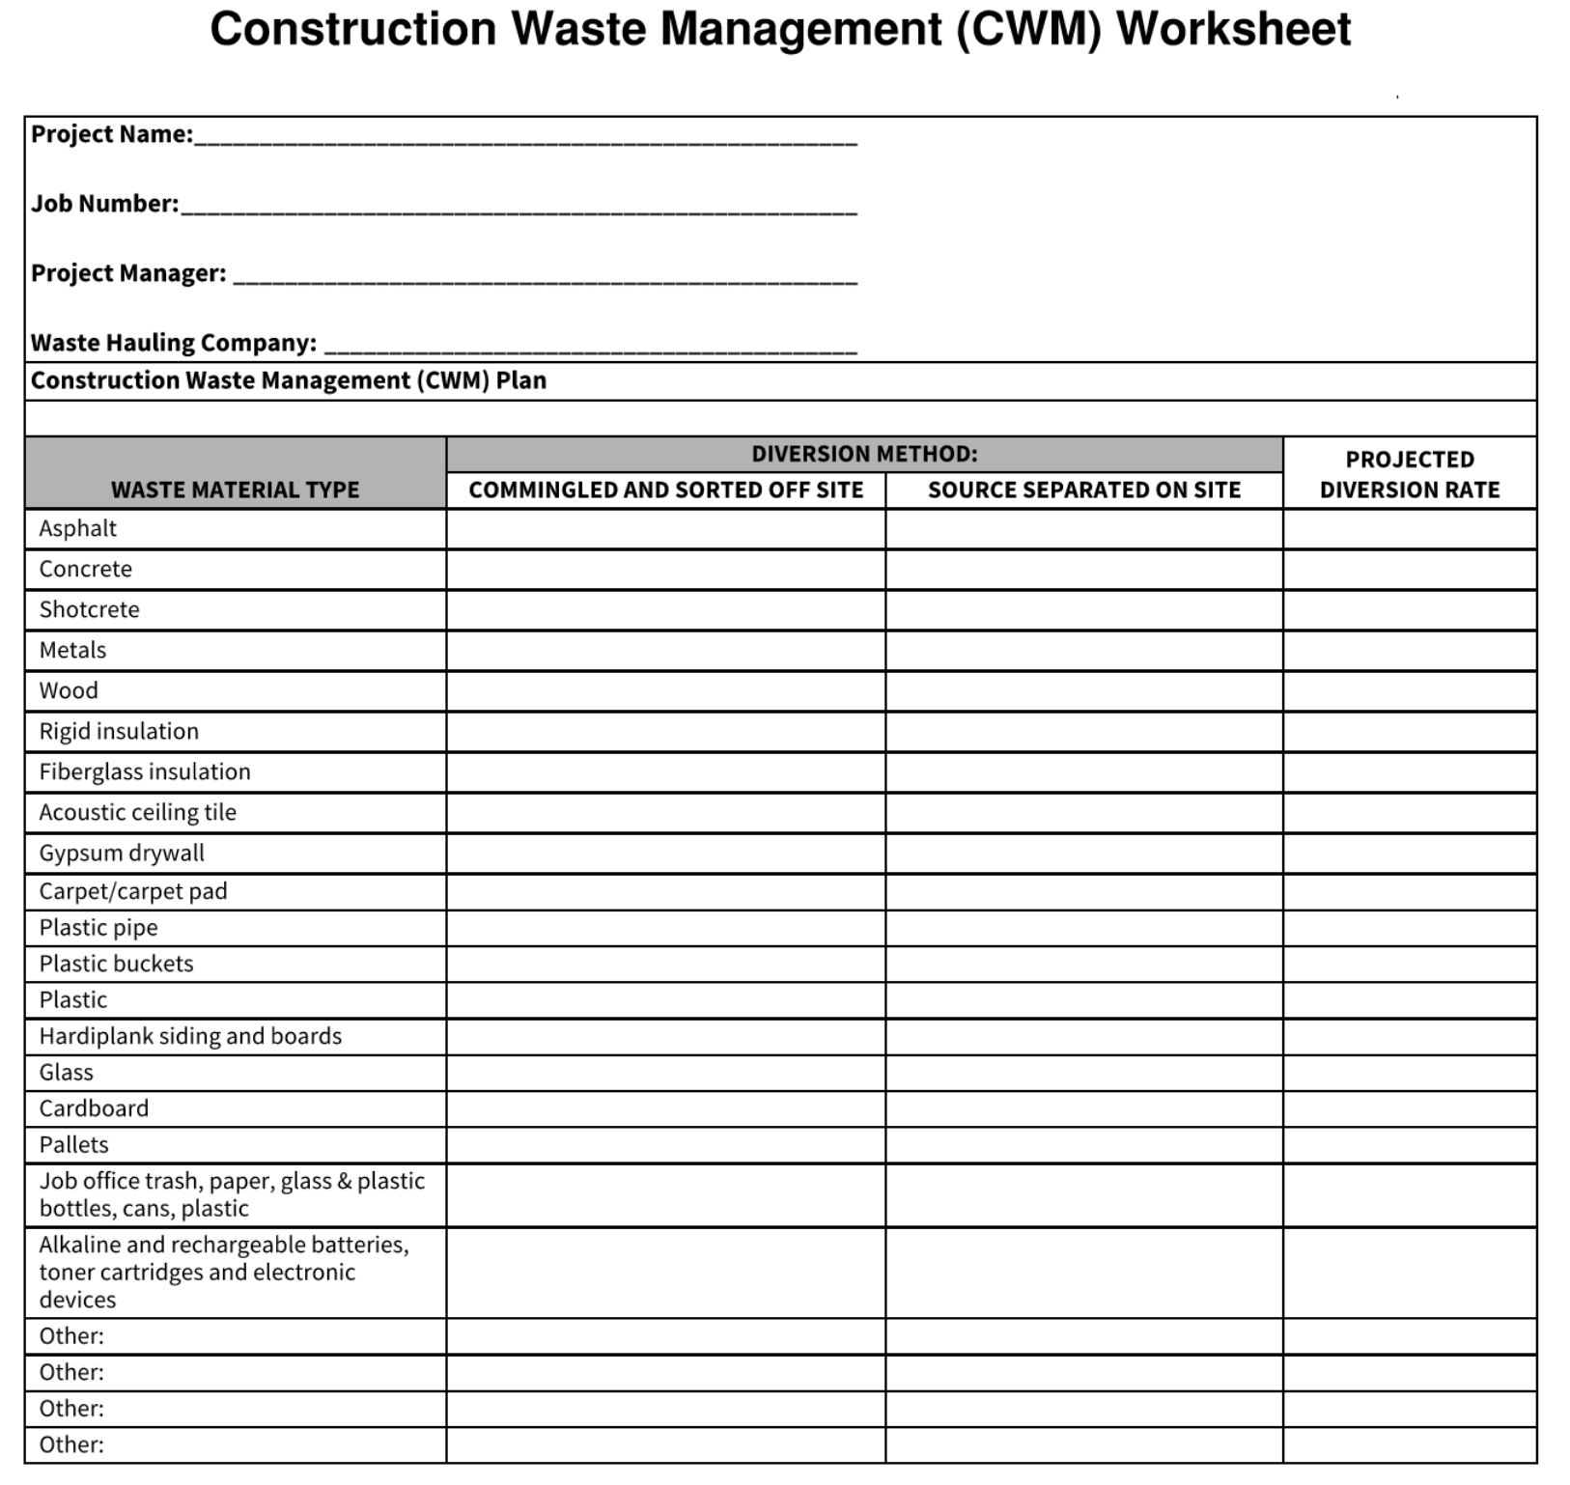
(Worksheet 1)

